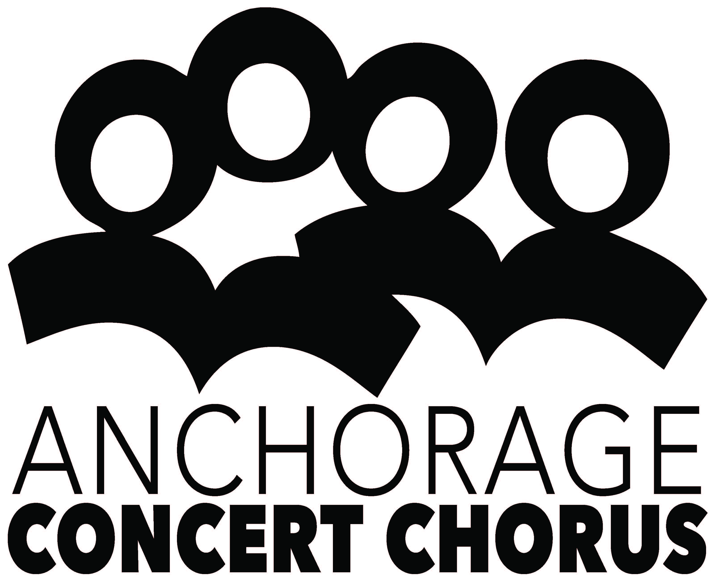
Program Advertisement Order Form

Advertiser: Phone:

Contact Name: Fax:

Title: E-mail:

Address:

To place an advertisement for the ACC concert programs and website for the 2017-2018 Season, please submit print-ready artwork to ACC by the following deadlines:
Concert Ad Due

 Family Holiday Pops, December 17, 2017 November 22, 2017

 Generations: Unity Through Music, May 5, 2018 April 2, 2018
Co-produced with Anchorage Youth Orchestras

Back Cover $650 (add color $200)

Inside front or back cover $550 (add color $200)

Full page  $450

6” W x 7-1/2”H

Half page  $325
Horizontal 6” W x 3-11/16 (3.6875)

Quarter page  $190
2-15/16” x 3-11/16”

Eighth page  $100 (business card)
(2-15/16” x 1-13/16”) horizontal only

Please attach your check or complete credit card payment information to this form,
or we will bill the business address above.
Make checks payable to Anchorage Concert Chorus. Thank you for your support!

Anchorage Concert Chorus
PO Box 100364, Anchorage AK 99510-00364
Phone: 907-274-7464 FAX: 907-563-5980
Roland Rydstrom, Executive Director, Mobile Phone: 317-840-7879
concertchorus@gci.net
www.anchorageconcertchorus.org

