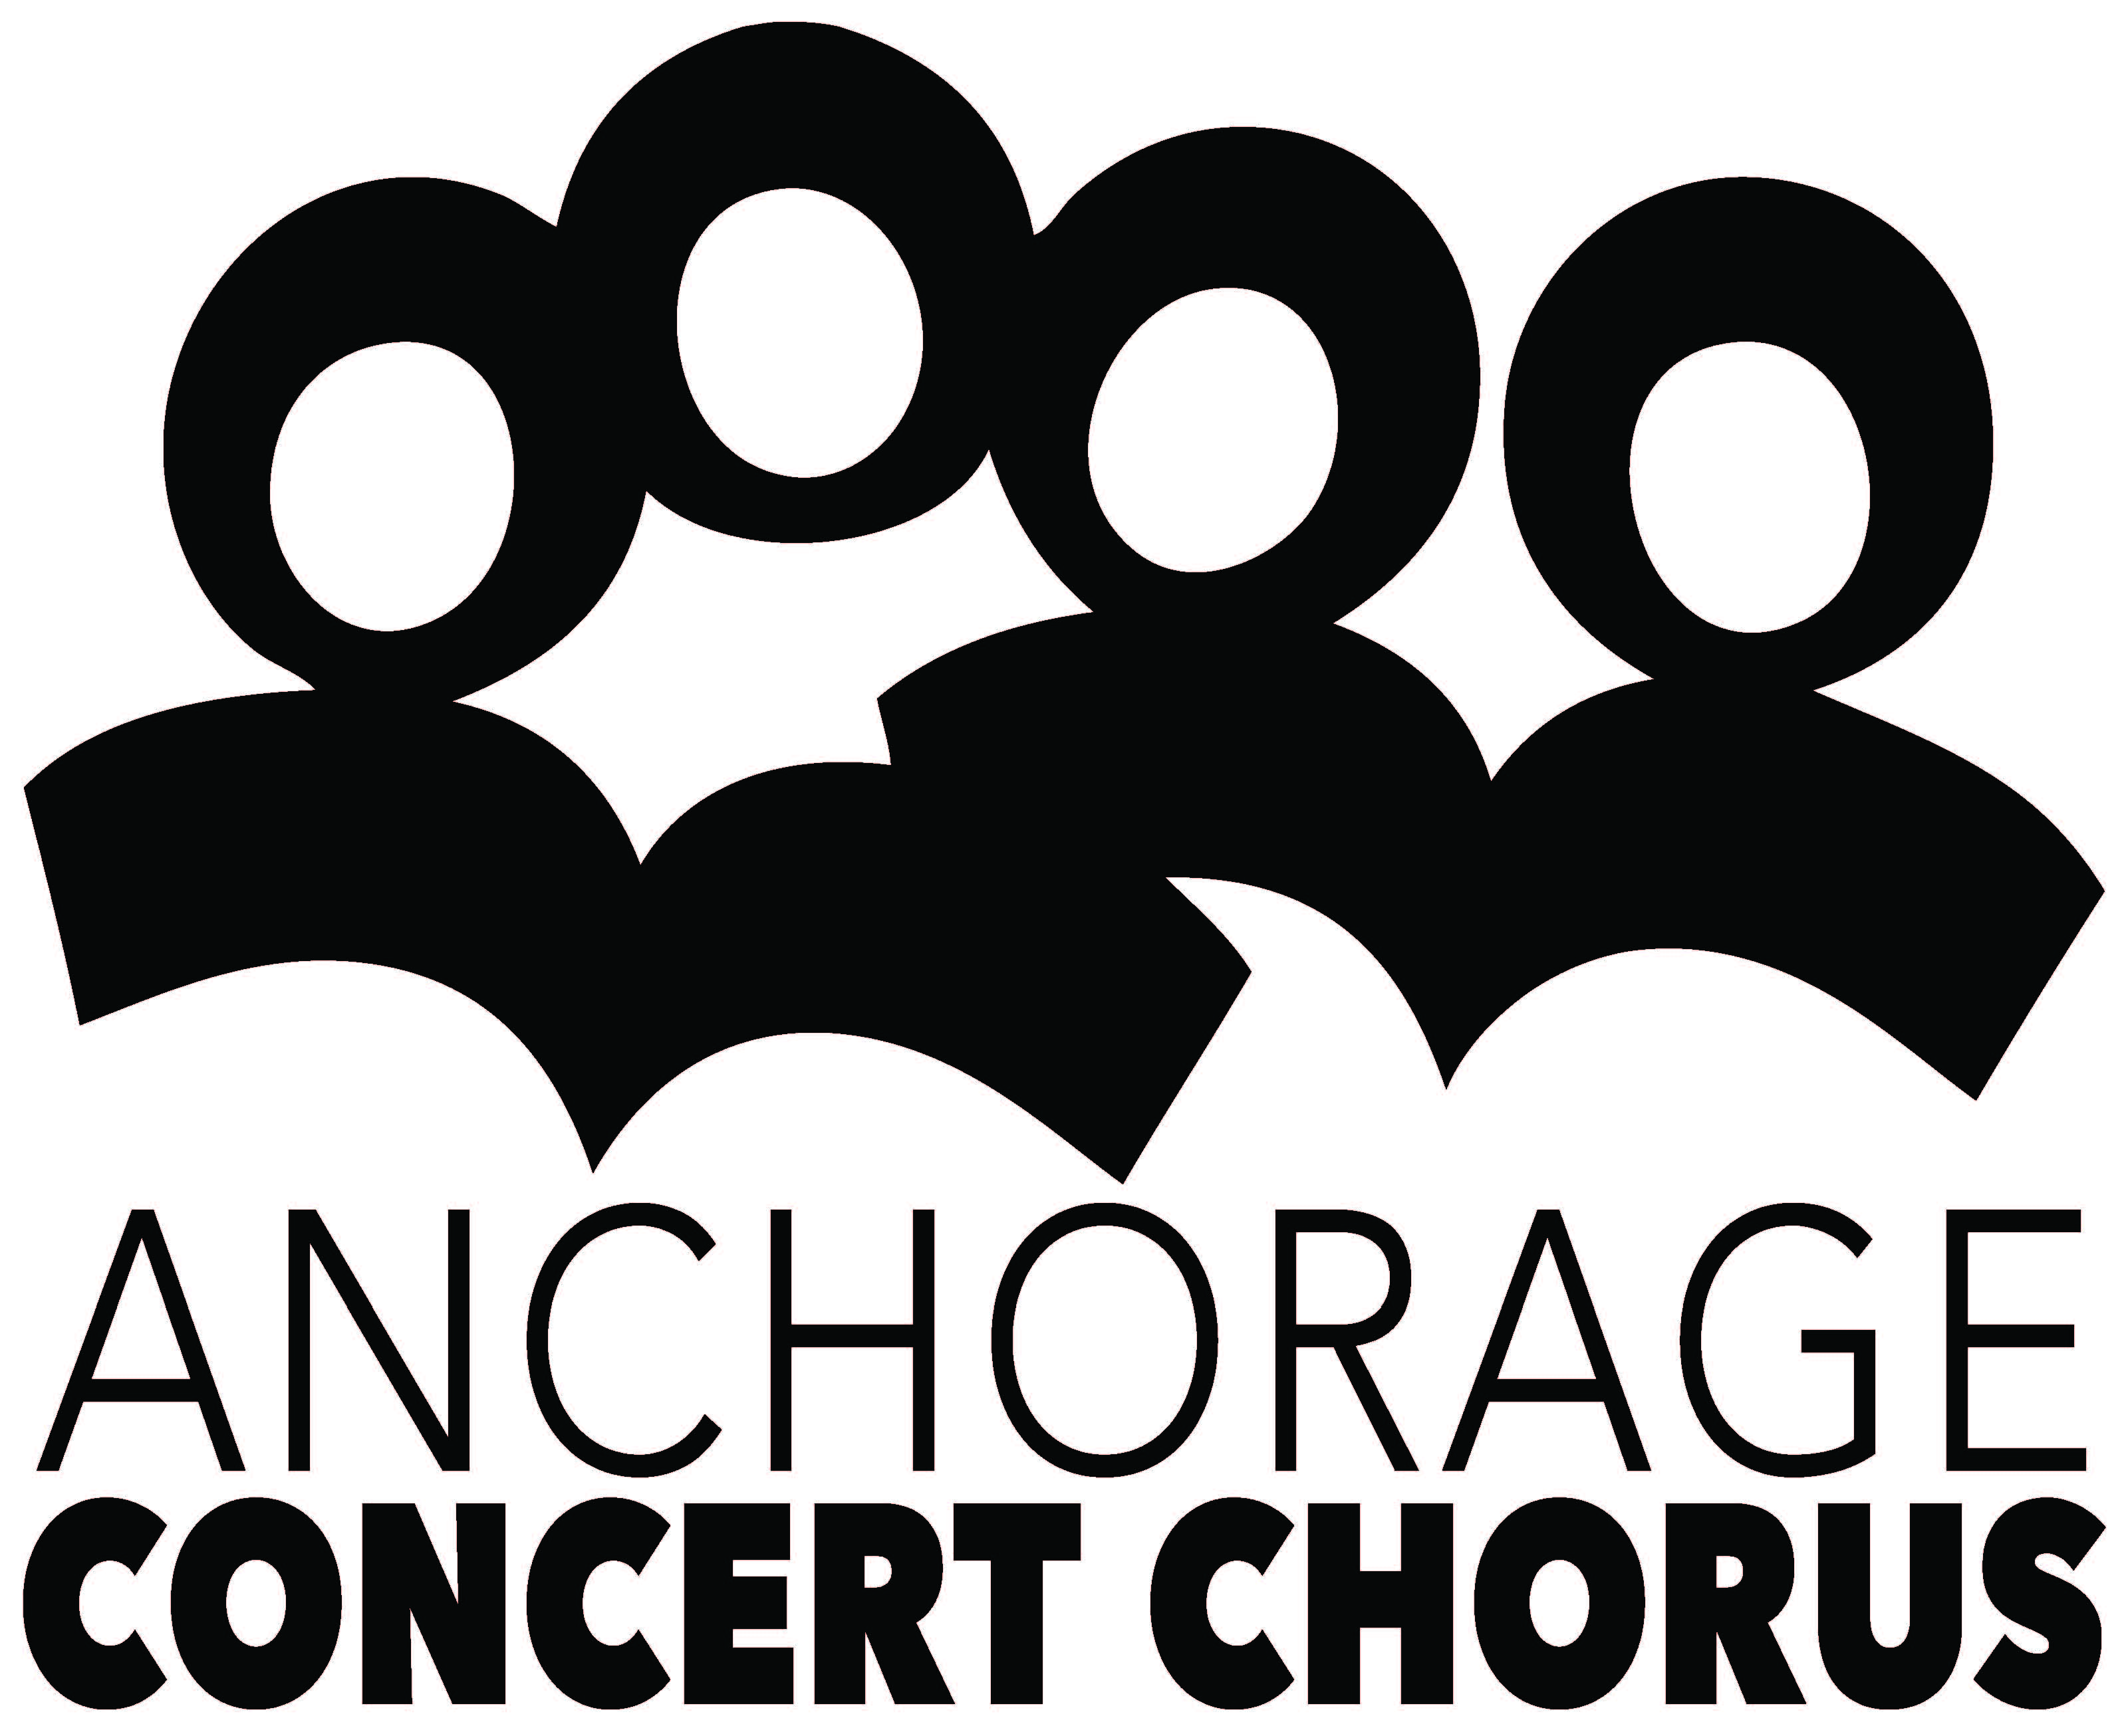
Program Advertisement Order Form

Advertiser: Phone:

Contact Name: Fax:

Title: E-mail:

Address:

To place an advertisement for the ACC concert programs and the ACC website for the 2018-2019 Season, please submit print-ready artwork to ACC by the deadlines outlined below. Note that although we don’t currently sell advertising space in the Community Messiah or The Big, Fun Chorus Benefit event programs, your business will be listed as an ACC season program advertiser.

Concert Ad Due

 Our Voice, October 14, 2018 September 21, 2018

 Family Holiday Pops, December 16, 2018 November 26, 2018

Back Cover $750 (add color $200) sold

Inside front or back cover $600 (add color $200) sold

Full page  $500

6” W x 7-1/2”H

Half page  $350
Horizontal 6” W x 3-11/16 (3.6875)

Quarter page  $225
2-15/16” x 3-11/16”

Eighth page  $110 (business card)
(2-15/16” x 1-13/16”) horizontal only

Please attach your check or complete credit card payment information to this form,
or we will bill the business address above.
Make checks payable to Anchorage Concert Chorus. Thank you for your support!

Anchorage Concert Chorus
Roland Rydstrom, Executive Director
PO Box 100364, Anchorage AK 99510-00364
Phone: 907-274-7464 FAX: 907-563-5980
concertchorus@gci.net
www.anchorageconcertchorus.org

