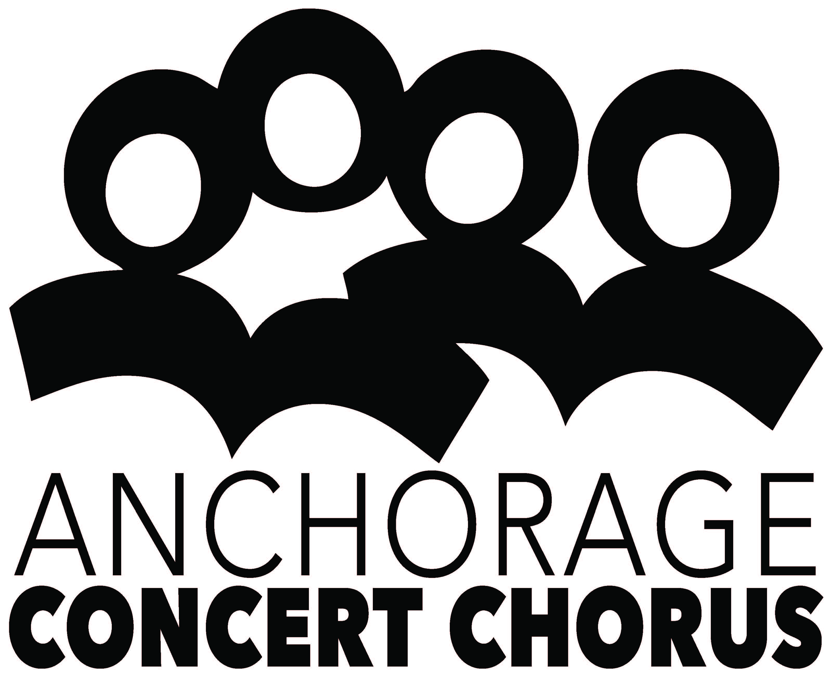

**Auction Item Donation Form**

**The Big, Fun Chorus Benefit**  
Anchorage Concert Chorus

165 E 56th Avenue, Anchorage, AK 99518

PO Box 100364, Anchorage AK 99510-0364

(907) 274-7464 phone (907) 563-5980 fax

[www.anchorageconcertchorus.org](http://www.anchorageconcertchorus.org)

concertchorus@gci.net

Item Number:

(To be completed by ACC)

**DONOR INFORMATION**

Donated By (anonymous) or NAME (as it will appear in the program.)

Contact Person

Address

City, State and Zip

Would the donor like an invitation? Yes No

**ITEM VALUE MINIMUM BID**

**BRIEF ITEM DESCRIPTION**

**(as it will appear in the event program)**

Donor’s Signature Date Event Committee Rep. Date

**This donation becomes the property of the Anchorage Concert Chorus (ACC) and is to be sold at an auction. The proceeds of the auction will go to the designee of ACC. The Donor has established the value for charitable tax deduction purposes. The value to be printed in the event program, however, will be determined by ACC. ACC reserves the right to combine donated items to create unique auction packages. The Donor grants the ACC the right to mention this donation in any promotional literature regarding the auction.**

EIN 23-7017298

PLEASE MAKE A COPY AND RETURN ORIGINAL TO CHORUS OFFICE