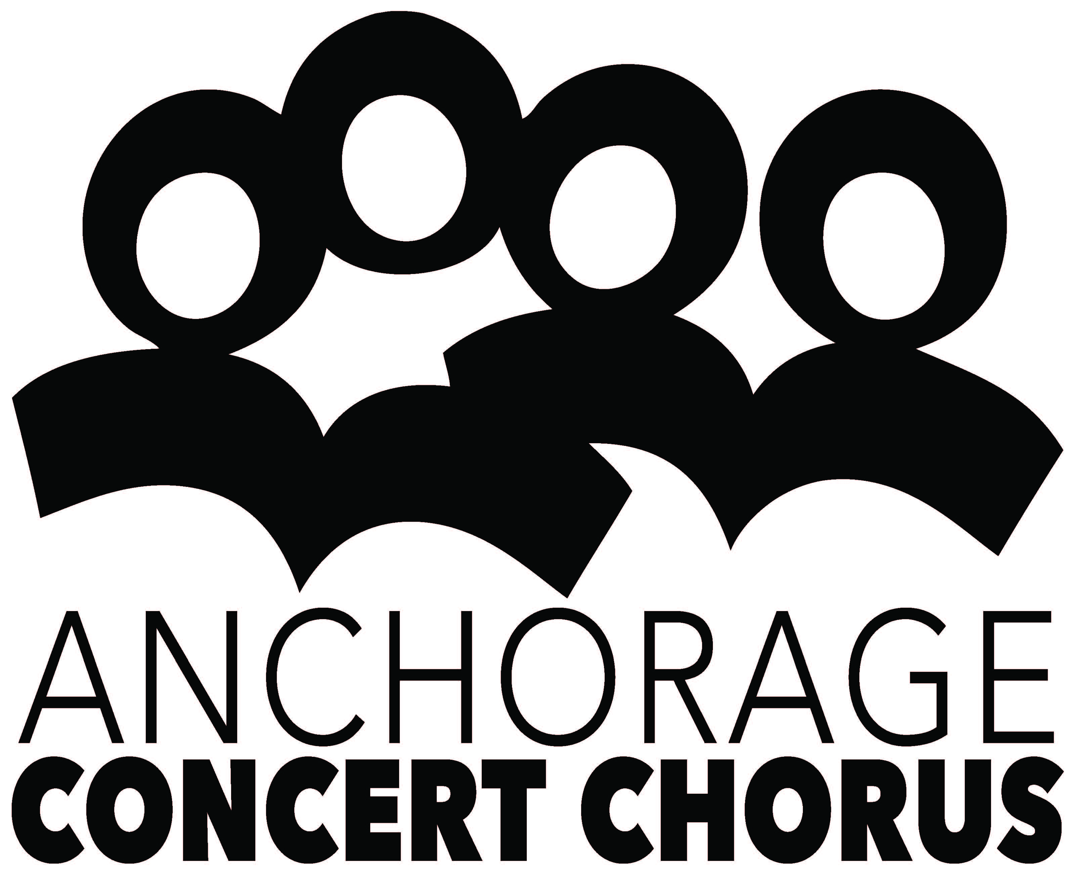

Founded in 1947

PHONE 907-274-7464
FAX 907-563-5980

ARTISTIC DIRECTOR/
CONDUCTOR
Grant Cochran, D.M.A.

EXECUTIVE DIRECTOR
Roland Rydstrom

PRESIDENT
Jennifer Midthun-Janes

PRESIDENT-ELECT
Megan Sandone

RECORDING SECRETARY
Sharon Higgins

CORRESPONDING
SECRETARY
Catherine Gage

TREASURER
Brian Blessington

DIRECTORS
Ann Binnian
Renee Downs
Cynthia Geiermann
Heidi Herbert-Lovern
Casey Carruth-Hinchey
Nan Magrath
Lana Ramos
Aggie Rivera
Pat Smith

February 10, 2018

Dear Generous Donor:

The Anchorage Concert Chorus was established in 1947 and is one of the oldest performing arts organizations in Alaska. We’re also the largest, with approximately 160 singers performing every year. We present three concerts per year at the Alaska Center for the Performing Arts, and participate in various community events such as the annual Mayor’s Tree Lighting, holiday caroling in public schools, and singing for various community and military ceremonies. We produce Community Messiah each December.

Our expenses are offset to a great extent by member dues, individual and corporate donations, foundation grants, and performance fees/tickets. But another important source of income is our annual fundraising event: The Big, Fun Chorus Benefit will be held Saturday, April 14 at 6:30 p.m. at O’Malley’s On The Green. This fun and unique fundraising evening will include musical bingo, karaoke for a cause, a wine wall, exciting silent and live auction items, and the announcement of the ACC Raffle winner. This isn’t your typical fundraiser!

We use donations as raffle items as well as for the silent and live auctions. We request that items have a value of at least $25. All contributions and donations are tax deductible; the ACC tax ID number is 23-7017298.

All donors for this fundraiser will be listed at the event and throughout the year on our website and in our concert programs. You’re further welcome to display promotional materials with your auction items at the event. Or if you’d rather make a financial contribution to help underwrite The Big, Fun Chorus Benefit, your support is welcome at all levels.

Please complete the attached donation form to ensure we have the correct item description, value and spelling of your name. I will contact you for item pick up. If you have questions, please call me at concertchorus@gci.net or 907-274-7464.

Your support helps Anchorage Concert Chorus continue to actively contribute to and participate in Anchorage’s vibrant arts community. Thank you for your support.

Sincerely,

Roland Rydstrom,
Executive Director

